**Module 1**

**DIGITAL IMAGE PROCESSING**

An ***image***is defined as a two dimensional function, **f(x,y),** where x and y are spatial (plane) coordinates, and the amplitude of **‘f’** at any pair of coordinates (x,y) is called the intensity or gray level of the image at that point.

A ***digital image*** is a 2D representation of a scene as a finite set of digital values, calledpicture elements or pixels or pels.

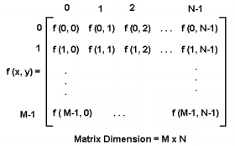

The field of ***digital image processing*** refers to processing digital image by means of a digital computer.

**NOTE:** A digital image is composed of finite number of elements like picture elements, image elements, pels, and pixels.

The digital image processing methods stems from 2 principal application areas:

1. Improvement of pictorial information for human interpretation
2. Processing of image data for storage, transmission and representation for autonomous machine perception.

**Fundamental Steps in Digital Image Processing \*\***

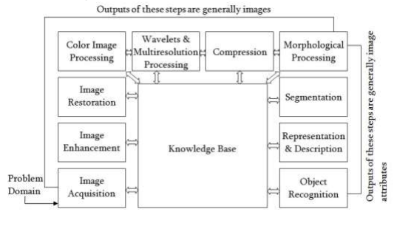

Figure 1.1 Fundamental steps in digital image processing.

***Image acquisition:*** This is the first step in the digital image processing. An image is captured by a sensor (such as digital camera) and digitized. The image that is acquired is completely unprocessed. This step involves preprocessing such as scaling.

***Image enhancement:*** It is the process of manipulating an image in order to make image more suitable than the original for the specific application. The image enhancement techniques are so verified, and use so many different image processing approaches. The idea behind enhancement techniques is to bring out detail that is hidden, or simply to highlight certain features of interest in an image like changing brightness & contrast etc.

***Image restoration:*** It is an area that also deals with improving the appearance of an image but it is objective than subjective, in the sense that restoration techniques tend to be based on mathematical or probabilistic models of image degradation.

***Color image processing:*** It is an area that has been gaining in importance because of the significant increase in the use of digital images over the internet. Color is used also for extracting features of interest in an image. This may include color modeling and processing in a digital domain etc.

***Wavelets:*** These are the foundation for representing images in various degrees of resolution. In particular used for image data compression and for pyramidal representation, in which images are subdivided successively into smaller regions.

***Compression:*** Deals with techniques for reducing the storage required to saving an image, or the bandwidth required to transmit it. An example for image compression standard is jpg file extension used in the JPEG(Joint Photographic Experts Group) image compression standard.

***Morphological processing:*** It deals with tools for extracting image components that are useful in the representation and description of shape.

***Segmentation:*** Segmentation procedures partition an image into its constituent’s parts or objects. In general, autonomous segmentation is one of the most difficult task in digital processing. A rugged segmentation procedure brings the process a long way towards successful solution of imaging problems that require objects to be identified individually. On the other hand, weak or erratic segmentation algorithms always guarantee eventual failure.

***Representation and description:*** It follows the output of the segmentation stage, which is raw pixel data it’s needed to convert it to a form suitable for computer processing. The first decision that must be made is whether the data should be represented as a boundary (i.e., the set of pixels separating one image region from another) or as a complete region.

* The boundary representation is appropriate when the focus is on external shape characteristics, such as corners and inflections.
* The regional representation is appropriate when the focus is on internal properties, such as texture or skeletal shape.

Description also called feature selection, deals with extracting attributes that result in some quantitative information of interest or are basic for differentiating one class of objects from another.

***Recognition:*** It is the process that assigns a label (e.g., ‘vehicle’) to an object based on its descriptors.

**Components of an Image Processing System\*\***

**Network**

**Image sensors**

**Image Displays**

**Computer**

**Mass storage**

**Hardcopy**

**Specialized image processing hardware**

**Image processing software**

**Problem domain**

**Figure 1.2 Components of a general – purpose image processing system.**

The above figure shows the basic components comprising a typical general purpose system used for digital image processing. With reference to ***sensing***, two elements are required to acquire digital images:

1. The physical device that is sensitive to the energy radiated by the object we wish to image.
2. Digitizer is a device for converting the output of the physical sensing device into digital form.

For example in a digital camera, the sensors produce an electrical output proportional to light intensity.

**Specialized image processing hardware** usually consists of the digitizer plus hardware that performs other primitive operations, such as an arithmetic logic unit(ALU), that performs other primitive operations in parallel on entire images. This type of hardware is called a ***front end subsystem***, and its most distinguished characteristic is speed, so this unit performs functions that require fast data throughputs that the typical main computer cannot handle.

The **Computer** in an image processing system is a general purpose computer and can range from a PC to a supercomputer. In dedicated applications, sometimes custom computers are used to achieve a required level of performance.

**Software** for image processing consists of specialized modules that perform specific tasks. A well designed package also includes the capacity for the user to write code that, as a minimum, utilizes the specialized modules.

**Mass storage** capacity is a must in image processing applications. An image 1024 X 1024 pixels, in which the intensity of each pixel is an 8-bit quantity, requires one megabyte of storage space if the image is not compressed. When dealing with thousands, or even millions, of images, providing adequate storage in an image processing applications falls into three principal categories:

1. Short term storage for use during processing
2. Online storage for relatively fast recall
3. Archival storage, characterized by infrequent access.

Storage is measured in bytes, Kbytes, Mbytes, Gbytes, Tbytes. One method of providing short term storage is computer memory. An-other is by specialized buffers, that store one or more images and can be accessed rapidly, usually at video buffers, that store one or more images and can be accessed rapidly, usually at video rates. The latter method allows virtually instantaneous image zoom, as well as scroll (vertical shifts) and pan (horizontal shifts). Online storage generally takes the form of magnetic disks or optical image storage. The key factor characterizing the online storage is frequent access to the stored data. Magnetic tapes and optical disks housed in ‘jukeboxes’ are the usual media for the archival applications.

**Image displays** in use today are mainly color TV monitors. Monitors are driven by the outputs of image and graphic display cards that are an integral part of the computer system. In some cases it is necessary to have stereo displays, and these are implemented in the form of head gear containing two small displays embedded in goggles worn by the users.

**Hardcopy** devices for recording images include laser printers, film cameras, heat-sensitive devices, inject units, such as optical and CD ROM disks. Film provides the highest possible resolution, but paper is the obvious medium of choice for written material.

**Networking** is almost a default function in any computer system in use today. Because of the large amount of data inherent in image processing applications, the key consideration in image transmission is bandwidth. Optical fiber and other broadband technologies overcoming the problem of communicating with remote sites via internet.

**Sampling and Quantization**

In signal processing sampling is the reduction of continues time-signal into discrete time-signal. We denote images by two-dimensional functions of the form f( x, y ). An image may be continues with respect to the x- and y- coordinates, and also in amplitude. To convert it to digital form, we have sampled the function in both coordinates and in amplitude. Digitizing the coordinate values is called sampling. Digitizing the amplitude values is called quantization.

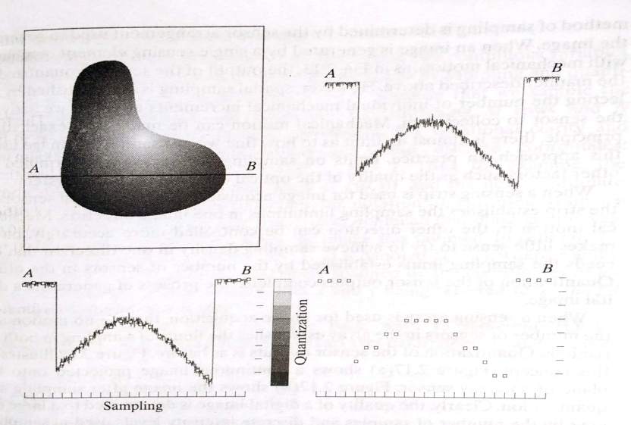

**Figure 1.3 Continues image, A scan line from A to B in the continues image, Sampling and quantization, Digital Scan line**

In fig. 1.3(a) shows a continuous image f that we want to convert to digital form. The one dimensional function in fig. 1.3(b) is a plot of amplitude values of the continuous image along the line segment AB in fig. 1.3(a). The random variations are due to image noise. To sample this function, we take equally spaced samples along the line AB, as shown in fig.1.3(c). The spatial location of each sample is indicated by a vertical tick mark in the bottom part of the figure. The samples are shown as small white squares superimposed on the function. The set of these discrete locations gives the sampled function. In order to form a digital function, the intensity values also must be converted into discrete quantities. The right side of the fig. 1.3(c) shows the intensity scale divided into eight discrete intervals, ranging from black to white. The vertical tic marks indicate the specific value assigned to each of the eight intensity intervals. The continuous intensity levels are quantized by assigning one of the eight values to each sample. The digital samples resulting from both sampling and quantization are shown in fig 1.3(d).

**Representing Digital Images**

Let f(s, t) represent a continuous image function of two continuous variables, s and t. We convert this function into a digital image by sampling and quantization. Suppose we sample the continuous image into a 2-D array, f(x,y), containing M rows and N columns, where (x,y) are discrete coordinates. For notational clarity and convenience, we use integer values for these discrete coordinates: x = 0,1,2,3,…M-1 and y = 0,1,2,3,…..N-1. In general, the value of the image at any coordinates (x,y) is denoted f(x,y), where x and y are integers. The section of the real plane spanned by the coordinates of an image is called the ***spatial domain,*** with x and y being referred to as spatial variables or spatial coordinates. The image displays allow us to view results at a glance. Numerical arrays are used for processing and algorithm development.

In equation form, we write the representation of an M X N numerical array as



Both the sides of this equation are equivalent ways of expressing a digital image quantitatively. The right side is a matrix of real numbers. Each element of this matrix is called an image element, pictures element, pixels, or pel. This digitization process requires that decisions be made regarding the values for M, N, and for the number L of discrete intensity levels. Here M and N are positive integers. The number of intensity levels typically is an integer power of 2:

L= 2k

The number, b of bits required to store a digitized image is b = ‘M’ x ‘N’ x ‘k’ When M = N, this equation becomes b = N2k

**Basic Relationships between Pixels**

A pixel p at coordinates ( x, y) has four horizontal and vertical neighbors whose coordinates are given by

(x+1, y), (x-1, y), (x, y+1), (x, y-1)

This set of pixels is called the 4-neighbors of P, and is denoted by N 4(P). Each of them are at a unit distance from P. The four diagonal neighbors of p(x,y) are given by,

(x+1, y+1), (x+1, y-1), (x-1, y+1), (x-1, y-1)

This set is denoted by N D(P). Each of them are at Euclidean distance of 1.414 from P. The points ND(P) and N4(P) are together known as 8-neighbors of the point P, denoted by N8(P). Some of the points in the N4, ND and N8 may fall outside image when P lies on the border of image.

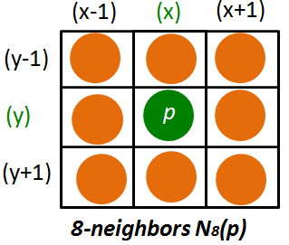

* N 4 - 4-neighbors
* N D - diagonal neighbors
* N 8 - 8-neighbors (N 4 U N D )

***Neighbors of a pixel***

1. 4-neighbors of a pixel p are its vertical and horizontal neighbors denoted by N4(p) 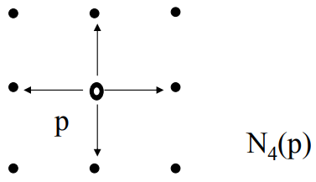 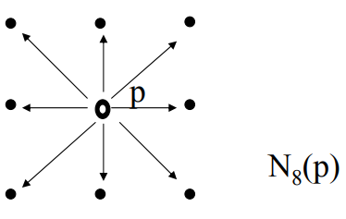
2. 8-neighbors of a pixel p are its vertical horizontal and 4 diagonal neighbors denoted by N8(p) is shown above.

**Adjacency, Connectivity, regions, and Boundaries**

***Adjacency:***Two pixels are connected if they are neighbors and their gray levels satisfy some specified criterion of similarity. For example, in a binary image two pixels are connected if they are 4-neighbors and have same value (0/1) then it is said to be satisfy adjacency.

Let V be set of gray levels values used to define adjacency.

***4-adjacency:*** Two pixels p and q with values from V are 4- adjacent if q is in the set N 4 (p).

***8-adjacency:*** Two pixels p and q with values from V are 8- adjacent if q is in the set N 8 (p).

***m-adjacency:***Two pixels p and q with values from V are madjacent if,

1. q is in N 4(P).
2. q is in N D(p) and the set N4(p) ∩ N4(q) is empty (has no pixels whose values are from V.

***Connectivity:*** To determine whether the pixels are adjacent in some sense. Let V be the set of gray-level values used to define connectivity; then Two pixels p, q that have values from the set V(1,2) are:

1. 4-connected, if q is in the set N4(p)

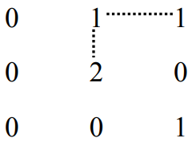

1. 8-connected, if q is in the set N8(p)

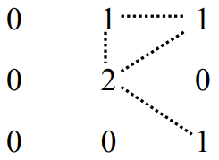

1. m-connected, if q is in N4(p) or q is in ND(p) and the set N4 (p) ∩ N4 (q) is empty

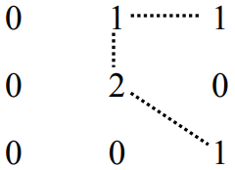

**Paths & Path lengths:**

A path from pixel p with coordinates (x, y) to pixel q with coordinates (s, t) is a sequence of distinct pixels with coordinates:

(x 0, y 0), (x 1, y 1), (x2, y 2) … (x n, y n),

where (x 0, y 0)=(x, y) and (x n, y n)=(s, t); (x i, y i ) is adjacent to (xi-1, yi-1) (1 ≤ i ≤ n) and ‘n’ is the length of the path. We can define 4-, 8-, and m-paths based on type of adjacency used.

**Connected Components:**

If p and q are pixels of an image subset S then p is connected to q in S if there is a path from p to q consisting entirely of pixels in S. For every pixel p in S, the set of pixels in S that are connected to p is called a connected component of S, If S has only one connected component then S is called Connected Set .

***Regions and Boundaries***

A subset R of pixels in an image is called a Region of the image if R is a connected set. The boundary of the region R is the set of pixels in the region that have one or more neighbors that are not in R. If R happens to be an entire image, then its boundary is defined as the set of pixels in the first and last rows and columns of the image and image has no neighbors beyond its border. Normally, when we refer to a region, we are referring to a subset of an image, and any pixels in the boundary of the region that happen to coincide with the border of the image are included implicitly as part of the region boundary.

**Distance Measure**

Given pixels p, q and z with coordinates (x, y), (s, t), (u, v) respectively, the distance function D has following properties:

1. **D(p, q) ≥ 0 [ D(p, q) = 0, iff p = q]**
2. **D(p, q) = D(q, p)**
3. **D(p, z) ≤ D(p, q) + D(q, z**)

The following are the different Distance measures:

* Euclidean Distance : **De(p, q) = [(x-s)2 + (y-t) 2 ]**
* City Block Distance: **D4(p, q) = |x-s| + |y-t|**

|  |  |  |  |  |
| --- | --- | --- | --- | --- |
|  |  | 2 |  |  |
|  | 2 | 1 | 2 |  |
| 2 | 1 | 0 | 1 | 2 |
|  | 2 | 1 | 2 |  |
|  |  | 2 |  |  |

* Chess Board Distance: **D8(p, q) = max(|x-s|, |y-t|)**

|  |  |  |  |  |
| --- | --- | --- | --- | --- |
| 2 | 2 | 2 | 2 | 2 |
| 2 | 1 | 1 | 1 | 2 |
| 2 | 1 | 0 | 1 | 2 |
| 2 | 1 | 1 | 1 | 2 |
| 2 | 2 | 2 | 2 | 2 |

In this case, the pixels with D8 distance from (x, y) less than or equal to some value r form a square centered at (x,y). For example, the pixels with D8 distance ≤ 2 from (x, y) form the following contains of constant distance: The pxels with D8 = 1 are the 8- neighbors of (x, y).

**Applications of Image Processing:**

The areas of application of digital image processing are so varied that some form of organization is desirable in attempting to capture the breadth of this field. One of the simplest ways to develop a basic understanding of the extent of image processing applications is to categorize images according to their application.

1. Medical imaging
2. Robot vision
3. Character recognition
4. Remote Sensing.

***Medical Imaging:***

**Gamma-Ray Imaging:** Major uses of imaging based on gamma rays include nuclear medicine and astronomical observations. In nuclear medicine, the approach is to inject a patient with a radioactive isotope that emits gamma rays as it decays. Images are produced from the emissions collected by gamma ray detectors**.**

**X-ray Imaging:** X-rays are among the oldest sources of EM radiation used for imaging. The best known use of X-rays is medical diagnostics, but they also are used extensively in industry and other areas, like astronomy. X-rays for medical and industrial imaging are generated using an X-ray tube, which is a vacuum tube with a cathode and anode. The cathode is heated, causing free electrons to be released. These electrons flow at high speed to the positively charged anode. When the electrons strike a nucleus, energy is released in the form of X-ray radiation. e energy (penetrating power) of the X-rays is controlled by a voltage applied across the anode, and the number of X-rays is controlled by a current applied to the filament in the cathode. The intensity of the X-rays is modified by absorption as they pass through the patient, and the resulting energy falling on the film develops it, much in the same way that light develops photographic film. In digital radiography, digital images are obtained by one of two methods:

(1) By digitizing X-ray films;

(2) by having the X-rays that pass through the patient fall directly onto devices (such as a phosphor screen) that convert X-rays to light.

***Robot Vision:***

Apart from the many challenges that a robot face today, one of the biggest challenge still is to increase the vision of the robot. Make robot able to see things, identify them.

1. Hurdle detection:

Hurdle detection is one of the common task that has been done through image processing, by identifying different type of objects in the image and then calculating the distance between robot and hurdles.

1. Line follower robot:

Most of the robots today work by following the line and thus are called line follower robots. This helps a robot to move on its path and perform some tasks. This has also been achieved through image processing.

***Character Recognition:***

* Optical Character Recognition
* Detecting License Plate
* Banking- To process the cheques
* Blind and visually impaired persons
* Legal department
* Retail Industry

***Remote Sensing:***

In the field of remote sensing, the area of the earth is scanned by a satellite or from a very high ground and then it is analyzed to obtain information about it. One particular application of digital image processing in the field of remote sensing is to detect infrastructure damages caused by an earthquake. Since the area effected by the earthquake is sometimes so wide, that it not possible to examine it with human eye in order to estimate damages. Even if it is , then it is very hectic and time consuming procedure. So a solution to this is found in digital image processing using remote sensing. An image of the affected area is captured from the above ground and then it is analyzed to detect the various types of damage done by the earthquake. The key steps include in the analysis are

1. The extraction of edges
2. Analysis and enhancement of various types of edges